**Associative Container : Set,Multiset,Map,Multimap**

**#include<iostream>**

**#include<set>**

**using namespace std;**

**int main()**

**{**

**string name[]={"Yukta","Vaishnavi","Shubhangi","Tina","Ankit","Pratik","Chetan"};**

**multiset<string,less<string> >nameset(name,name+8);**

**multiset<string,less<string> >::iterator itr;**

**nameset.insert("Pratik");**

**nameset.insert("Vaishnavi");**

**nameset.insert("yukta");**

**nameset.insert("Ankit");**

**nameset.insert("shubhangi");**

**cout<<"size"<<nameset.size();**

**cout<<endl;**

**for(itr=nameset.begin();itr!=nameset.end();itr++)**

**{**

**cout<<*itr <<" ";**

**return 0;**

**}**

**Set :**

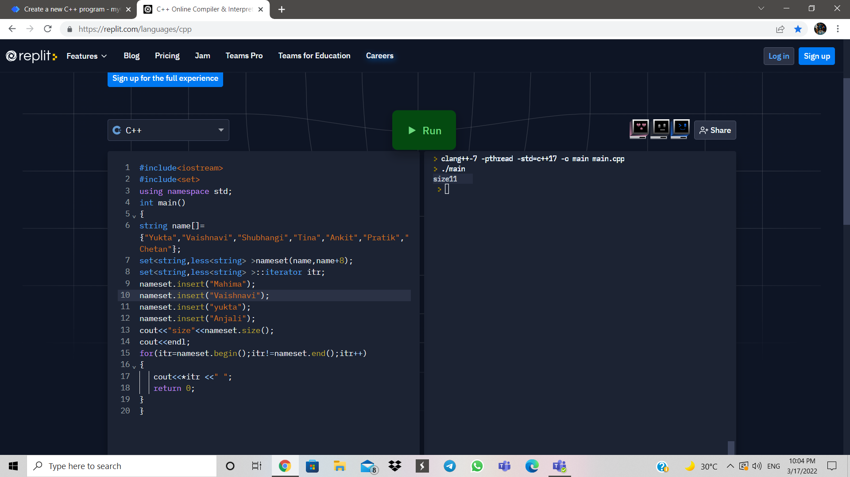

**Multiset:**

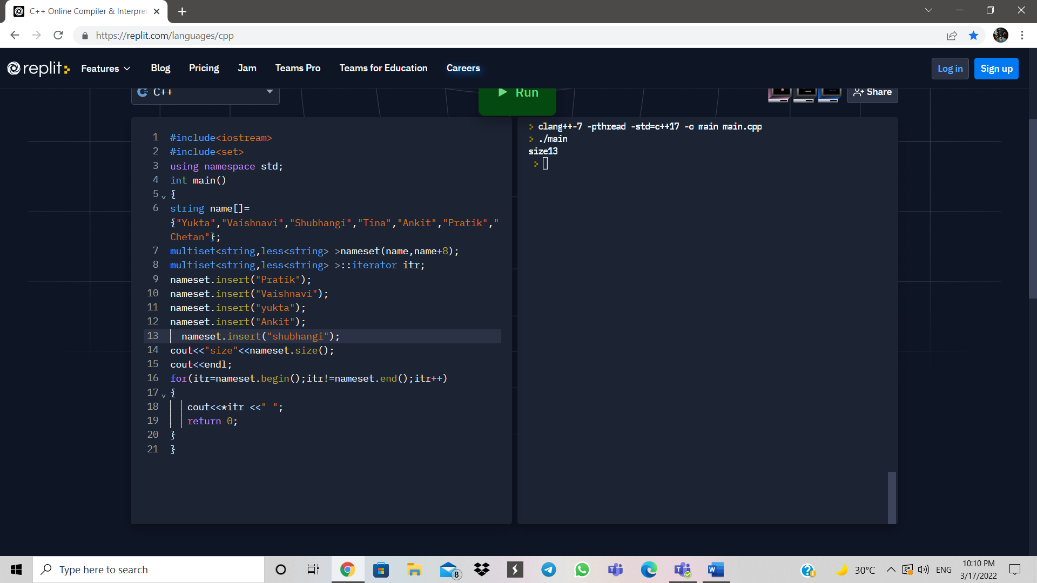

**Map :**

**#include <iostream>**

**#include<map>**

**using namespace std;**

**int main()**

**{**

**string name;**

**int pop;**

**string Country[]={"South-Korea","India","Russia","Afrika","Swizerland ","Australia","Katar","Irak"};**

**int pops[]={60000,125000,45000,98840,76000,29000,1399,3000};**

**map<string,int,less<string> >mapCountry;**

**map<string,int,less<string> >::iterator itr;**

**for(int i=0;i<7;i++)**

**{**

**name=Country[i];**

**pop=pops[i];**

**mapCountry[name]=pop;**

**}**

**cout<<"Enter Country: ";s**

**cin>>name;**

**pop=mapCountry[name];**

**cout<<"Population: "<<pop<<",000\n";**

**cout<<endl;**

**for(itr=mapCountry.begin();itr!=mapCountry.end();itr++)**

**cout<<(*itr).first<<" "<<(*itr).second<<",000\n";**

**return 0;**

**}**

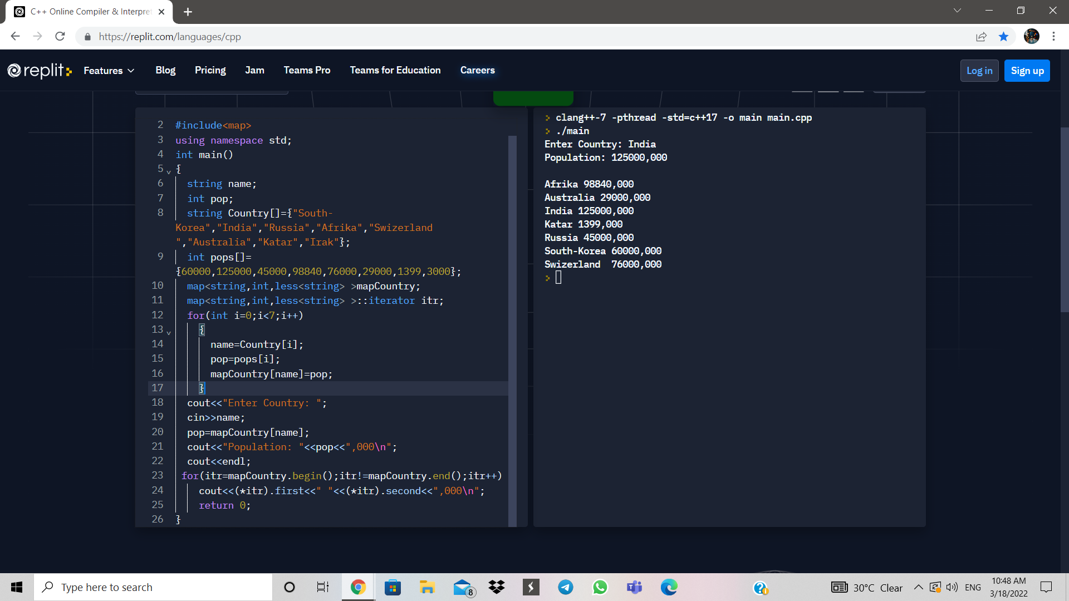

**Reverse function in file**

#include <iostream>

#include<fstream>

using namespace std;

int main()

{

ofstream ofile("abc.txt");

ofile<<"Welcome\n";

ofile<<"North Maharastra University";

ofile.close();

fstream ifile;

char j;

int i;

ifile.open("abc.txt", ios::in);

cout<<"Data in file : \n"<<endl;

ifile.seekg(0, ios::end);

int p = ifile.tellg();

for(i=1;i<=p;i++)

{

ifile.seekg(-i,ios::end);

ifile.get(j);

cout<<j;

}

ifile.close();

}

